**Name: Yonas Haftom**

**Course: Computer Sciences**

**Assignment Title: Building website Using HTML, CSS, and JAVASCRIPT**

**Submission Date: 27 Jan 2023**

**Introduction**

Web development refers to**building, creating, and maintaining websites**. It includes aspects such as web design, web publishing, web programming, and database management. While the terms "web developer" and "web designer" are often used synonymously, they do not mean the same thing.

This project is all about building An AI website that will give a clear idea of Artificial intelligence, its history, what creatures is been made in AI Facilities these days, and how AI benefits People and the world there is some link provided for those who want to learn about AI that will show what are the opportunities they will get if they are interested studying it take it as a future occupation.

**World Wide Web Consortium validator printout**

**I have checked if all my web page and CSS is validated, and I got lots of warnings and Errors.**

**Then I fixed some of them but I had some errors that I couldn’t fix because of the JavaScript affection for example on the history page I used a duplicate Attribute in one of the JavaScript functions which is Slide show so basically, I created a same class for each slide give them to display none when the slides click.**

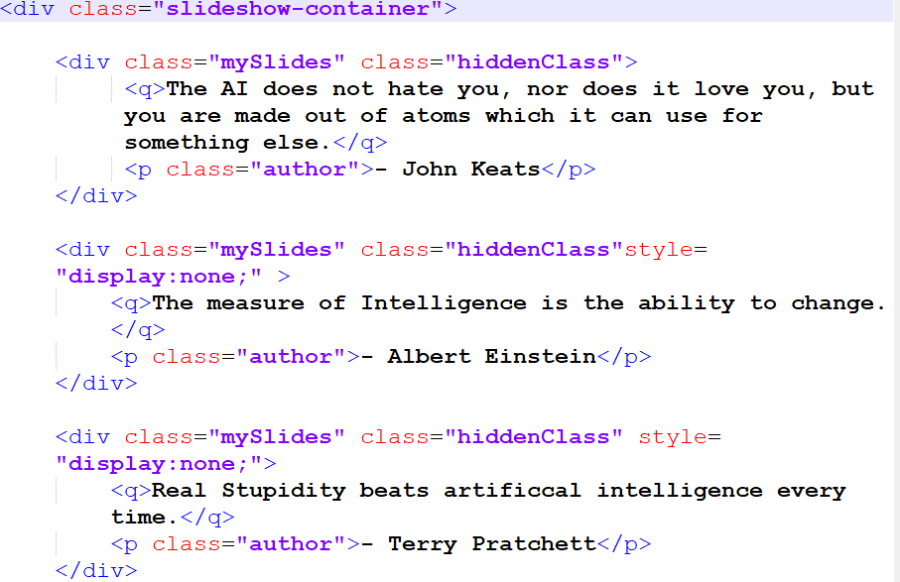

**Also, I tried to fix some errors which affect my web page.**

**Example:- this error says the link blow has no effect on my page, however..**

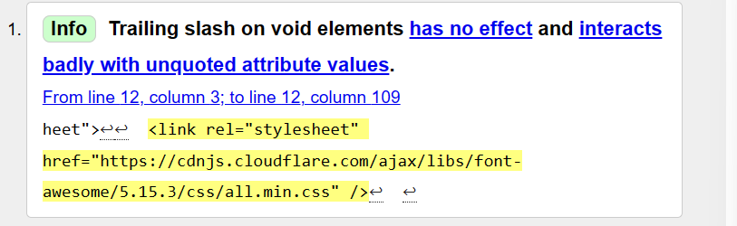

**The picture below happened after I believed the link has no effect and removed it**

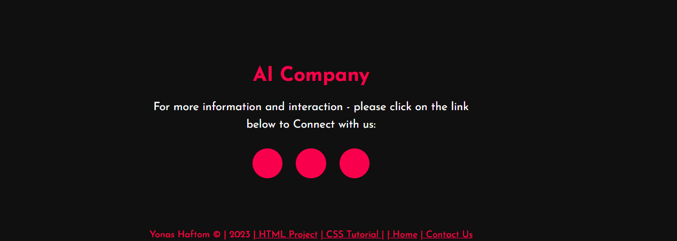

**The link in the picture will display all the signs of Facebook or Twitter and all Cloudflare on my page.**

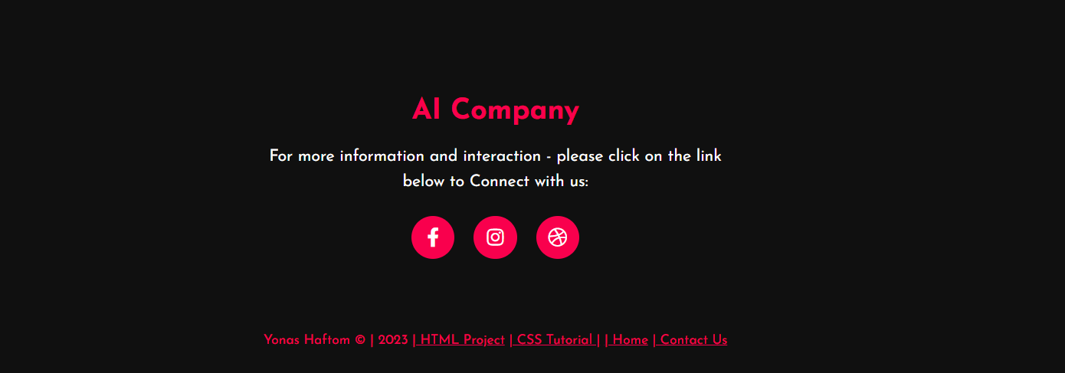

**Index/Home page**

**10 errors**

**7 warnings**

**1 info**

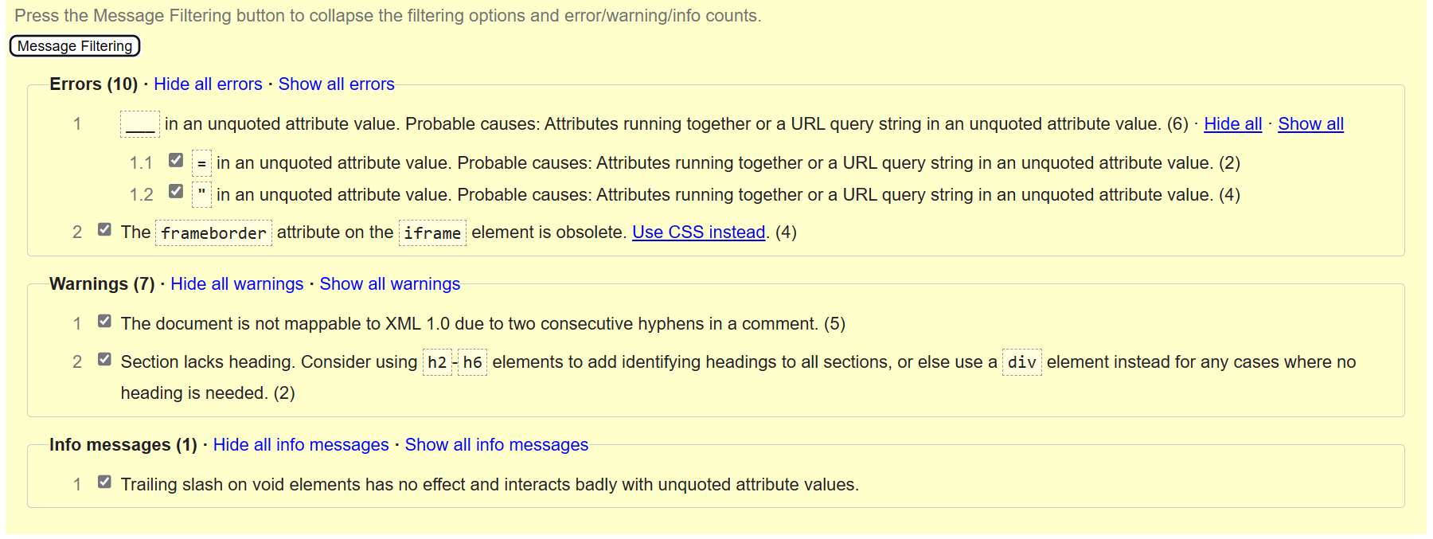

**History page**

**5 errors**

**5 warnings**

**1 info**

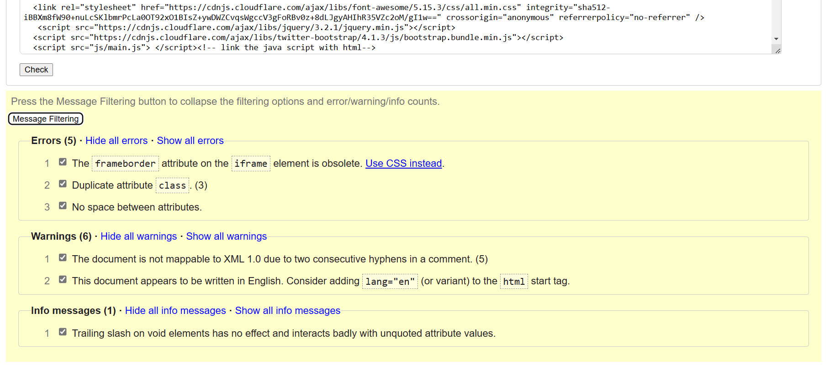

**Robots Page**

**0 errors**

**41 warnings**

**1 info**

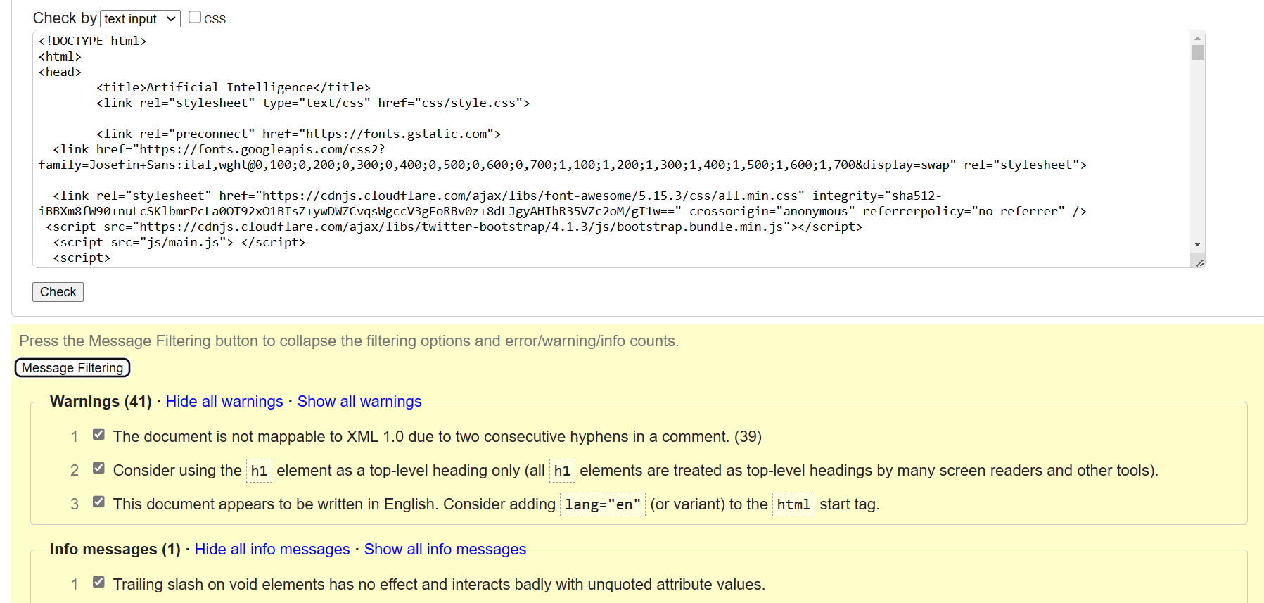

**Contact us page**

**0 errors**

**4 warnings**

**1 info**

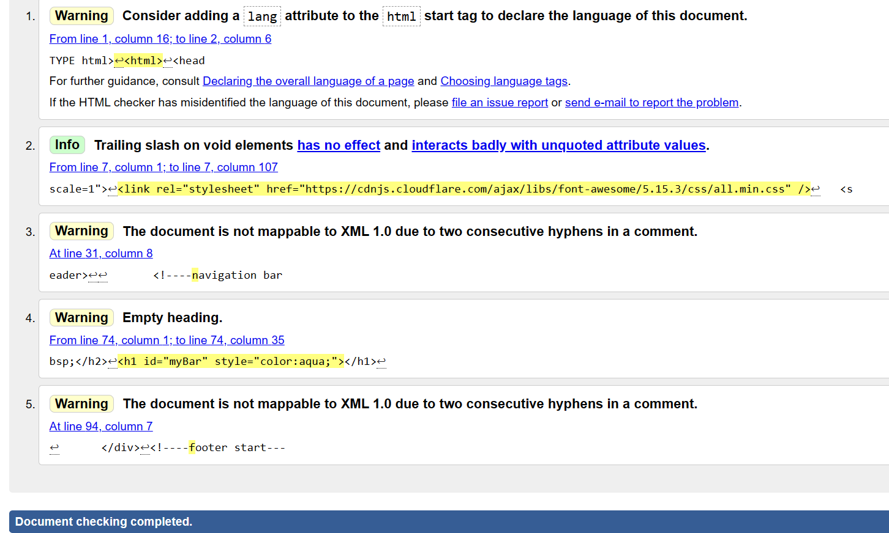

**CSS for all pages**

0 errors

0 warnings

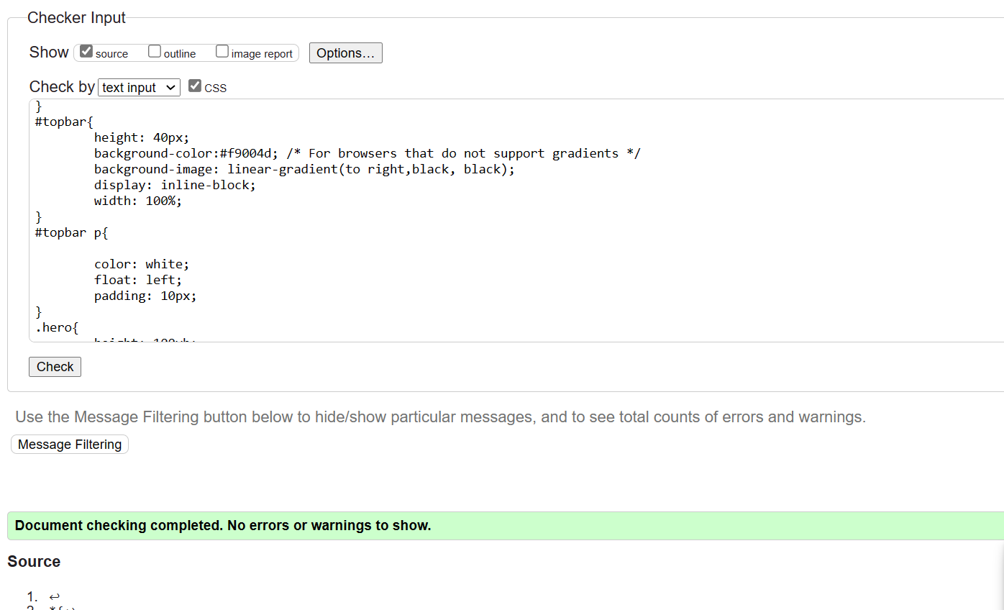

**CSS for contacting us**

**0 errors**

**0 warnings**

The reason I created another CSS for the contact us page is that it was interacting with all pages when I try to implement javascript functions.

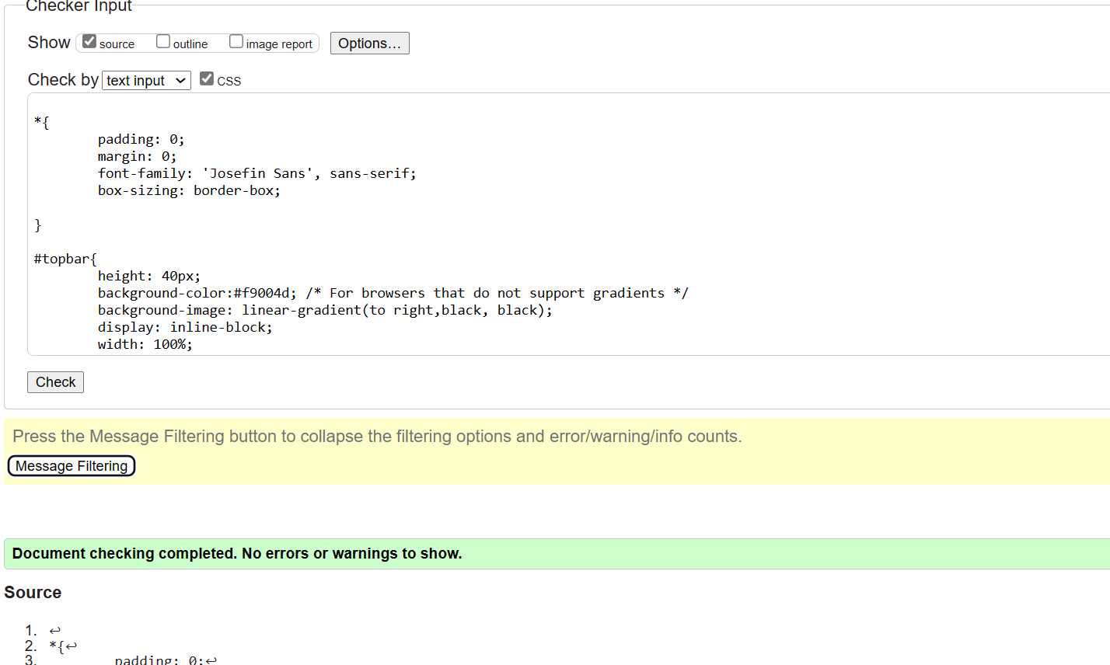

**the development of hypertext mark-up language (HTML)**

**Hypertext markup language (HTML)** is a Hypertext markup language, the standard markup language for documents designed to be displayed and viewed online by a browser also helps to create the structure of the web page. because it is a markup language, it consists of many tags. There are tags to display text, tables, ordered lists and unordered lists, etc. The HTML page has two main sections: head and body. The data that describes the page also termed metadata is inside the head section while the body section includes all the tags that are necessary to represent the visible content of the web page HTML is a platform-independent language so that can be made in use in any platform like Windows, Linux, Macintosh, etc.

**Examine different HTML versions and backward compatibility issues.**

Let’s see the significance of the individual Versions of Html in detail**. HTML 1.0**

* The basic version of HTML has support for basic elements like text controls and images. This was the very basic version of HTML with less support for a wide range of HTML elements. It does not have rich features like styling and other things that were related to how content will be rendered in a browser.
* The initial version of HTML does not provide support for tables, font support, etc., as it provides us in the latest version.
* We would also like to discuss that W3C did not exist before HTML 2.0; hence it does not show details about HTML 1.

**2. HTML 2**

* HTML version 2.0 was developed in 1995 with the basic intention of improving HTML version 1.0.
* Now a standard got started developed so as to maintain common rules and regulations across different browsers. HTML 2.0 has improved a lot in terms of markup tags. In the HTML 2.0 version concept of form came into force. Forms were developed, but still, they had basic tags like text boxes, buttons, etc.
* Also, the table came as an HTML tag. Now, in HTML tag 2.0, browsers also came with the concept of creating their own layers of tags that were specific to the browser itself. W3C was also formed. The main intention of W3C is to maintain standard across different web browsers so that these browsers understand and render HTML tags in a similar manner.

**3. HTML 3.2**

* It was developed in 1997. After HTML 2.0 was developed, the next version of HTML was 3.2
* With version 3.2 of HTML, HTML tags were further improved. It is worth noting that because of W3C standard maintenance, the newer version of HTML was 3.2 instead of 3.
* Now, HTML 3.2 has better support for new form elements. Another important feature that HTML 3.2 implemented was support for CSS. CSS stands for Cascading Style Sheet. It is CSS that provides features to make HTML tags look better on rendering it on browsers. CSS helps to style HTML elements.
* With the upgradation of browsers to HTML 3.2, the browser also supported for frame tags, although HTML specifications still do not support frame markup tags.

**4. HTML 4.01**

* It was developed in 1999. It extended the support of cascading styling sheets. In version 3.2, CSS were embedded in HTML page itself. Therefore, if the website has various web pages to apply to the style of each page, we must place CSS on each web page. Hence there was a repetition of the same block of CSS.
* To overcome this thing, in version 4.01 concept of an external styling sheet emerged. Under this concept, an external CSS file could be developed, and this external styling file could be included in HTML itself. HTML 4.01 provided support for further new tags of HTML.

**5. HTML5**

* This is the latest version of HTML. For a developer, it could be used in 2014. It came up with lots of HTML tag support. HTML5 provided support for new form elements like input elements of different types; geolocations support tags, etc.

**Let us look at a few of the tags which were added to HTML5.**

* **Email –**New HTML5 tag, which was added, is the input element of type email. This is a form tag, although it could also be used outside of a form tag. This tag checks the validation of the input value. It checks whether the value inserted is a valid email.
* **Password –**This is another form tag that was added to receive a password from the user. Being the password type field, the user types in the field are not visible directly to the user but are represented by special symbols. These symbols save the password from getting revealed on the browser.
* **Audio tag –**This is a new audio tag that was implemented in HTML5. This tag helps to add audio to our web page. We can use this tag to embed an audio clip into a web page. This audio tag could be played on a webpage.
* **Semantic tags –**Semantic tags are also known as structural tags. Structural tags are the tags that provide structure to the HTML page. It helps it divide the HTML page into different structures. These structures get combined into an HTML page itself to form an HTML web page. Few of the important HTML semantic tags are figcaption, <header>, <footer>
* **Section tag –**This tag is used to semantic a section in an HTML page. A section tag represents a section on a web page.

**W3C HTML Validator**

An HTML validator is a web-based tool that is used to maintain or check whether a piece of HTML tag or HTML is valid. An HTML validator follows the standard of W3C to validate an HTML page. It follows the W3C standard.

**Examine the advantages and disadvantages of coding HTML and using HTML editors.**

**Advantages:** 

* HTML helps to build the structure of a website and is a widely used Markup language.
* It is easy to learn.
* Every browser supports HTML Language.
* HTML is light weighted and fast to load.
* Storage of big files is allowed because of the application cache feature.
* Do not get to purchase any extra software because it’s by default in every window.
* Loose syntax (although, being too flexible won’t suit standards).
* HTML is simple to edit as plain text.
* It integrates easily with other languages such as JavaScript, CSS, etc.
* HTML is that it is easy to code even for novice programmers.
* HTML also allows template utilization, making designing a webpage easily.
* It is fast to download as the text is compressible.
* Very useful for beginners in the web designing field.
* HTML can be supported by each and every browser, if not supported by all browsers.
* HTML is built on almost every website, if not all websites.
* HTML is increasingly used for data storage like XML syntax.
* HTML has many tags and attributes which can shorten your line of code.

**Disadvantages:** 

* It cannot produce dynamic output alone, since it’s a static language.
* Making the structure of HTML documents becomes tough to understand.
* Errors can be costly.
* It is time-consuming as the time it consumes to maintain the colour scheme of a page and to make lists, tables, and forms.
* We need to write a lot of code for just creating a simple webpage.
* We have to check the deprecated tags and confirm not to use them to appear because another language that works with HTML has replaced the first work of the tag, and hence the opposite language needs to be understood and learned.
* Security features offered by HTML are limited.
* If we need to write down long code for creating a webpage then it produces some complexity.
* HTML can create only static and plain pages so if we’d like dynamic pages then HTML isn’t useful.
* Editing of the web page needs to be done separately, they are not centralized.

Screenshots of the website.

**Home page**







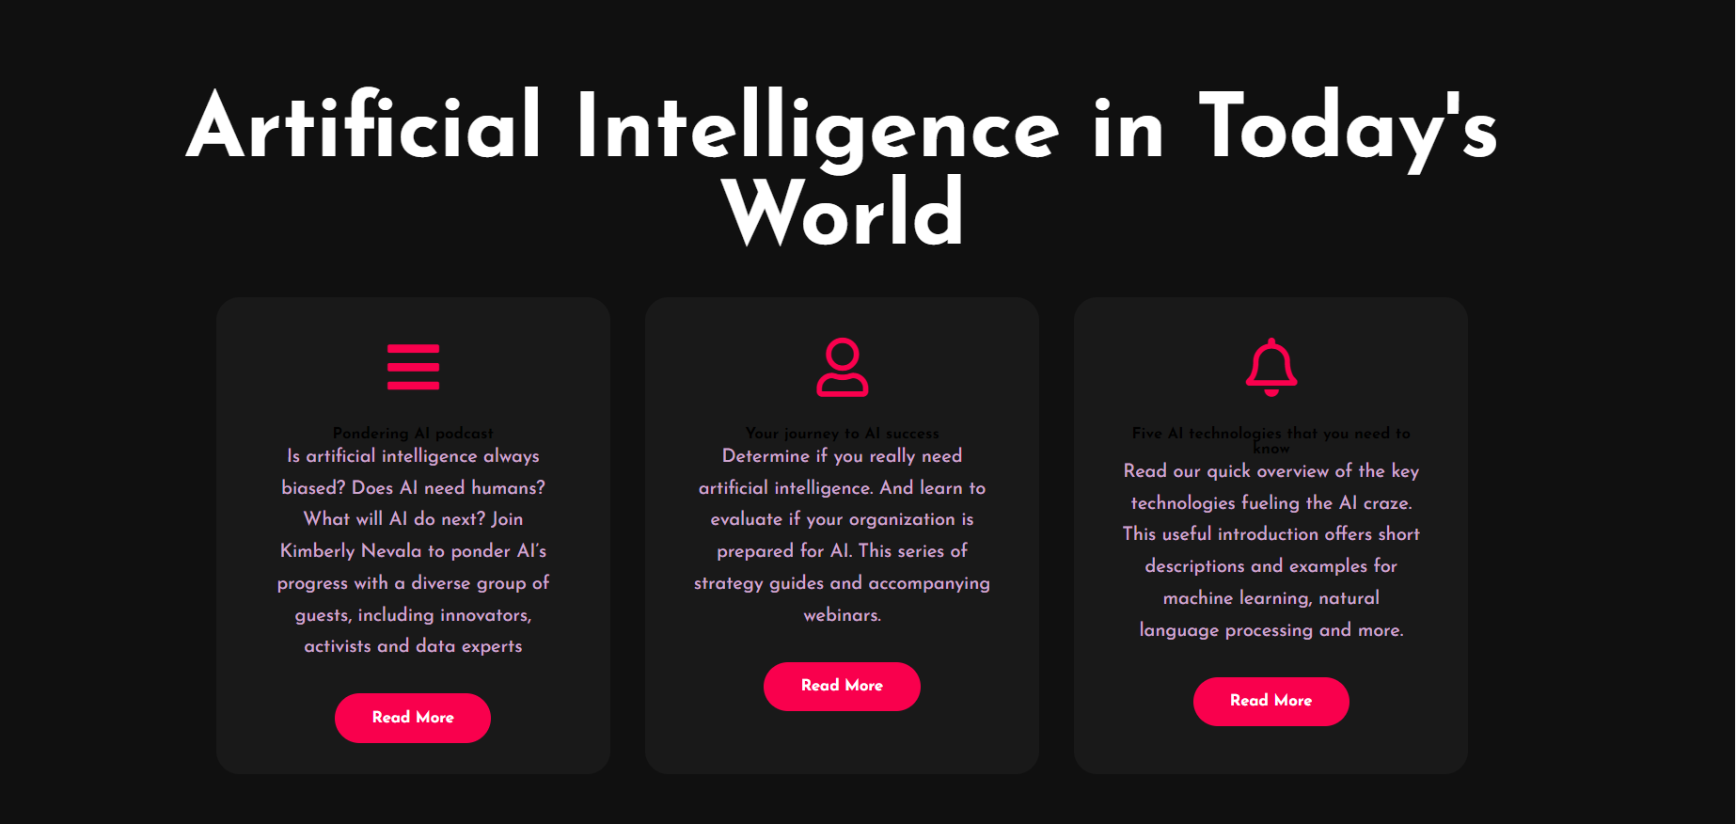

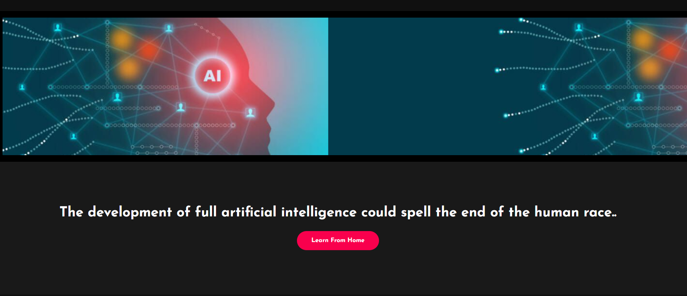

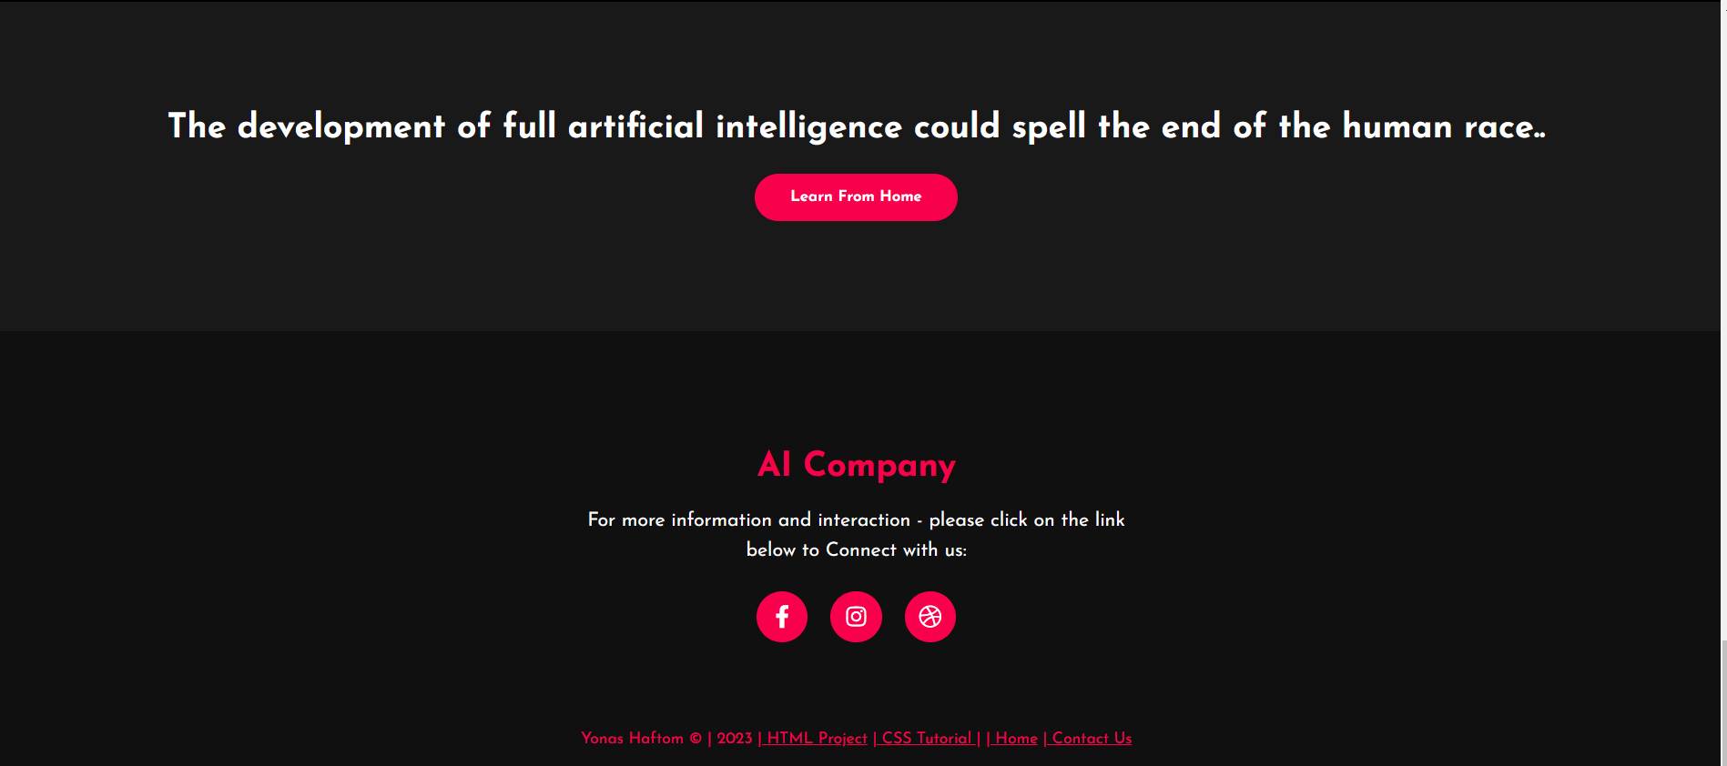

**History Page**

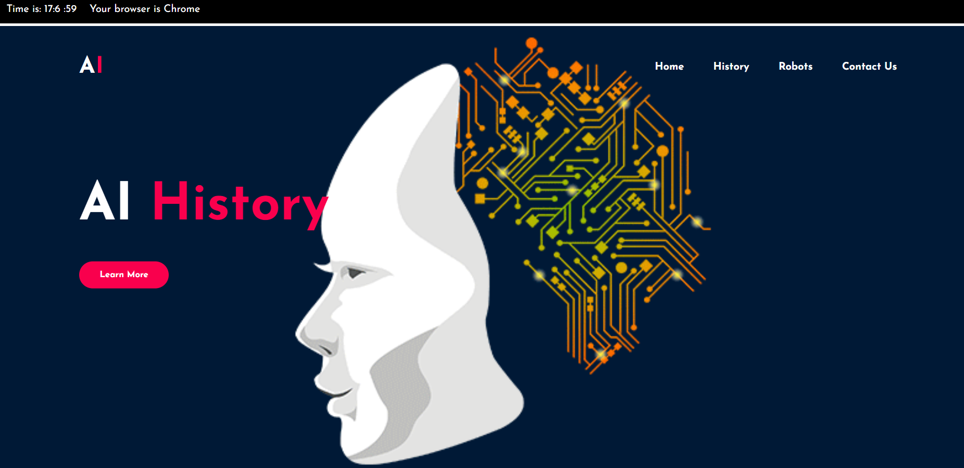





**Dynamic frame**



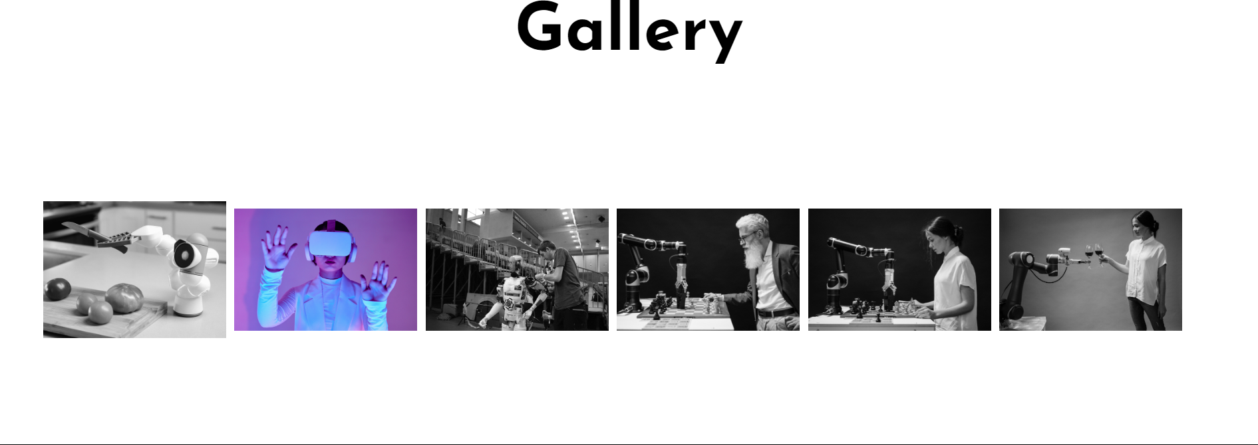

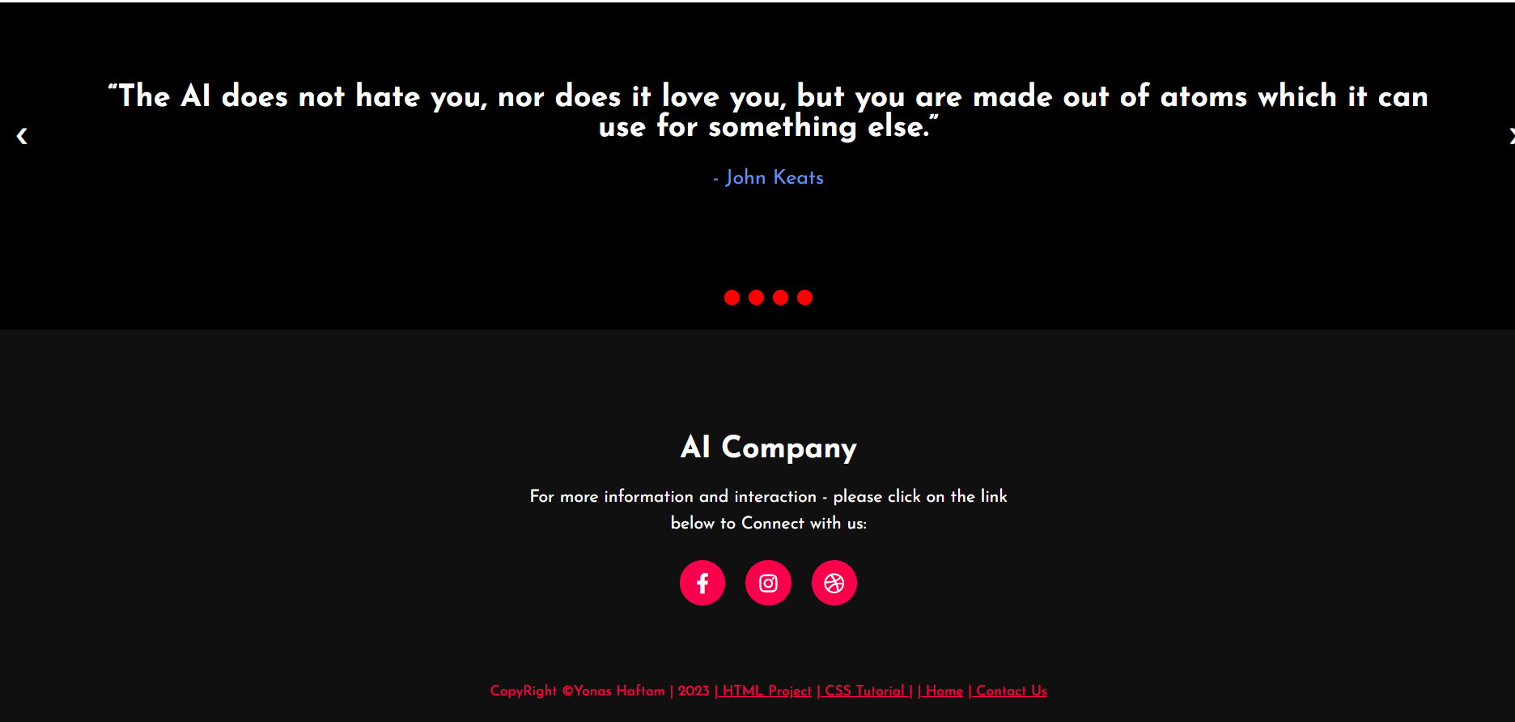

**Robots Page**

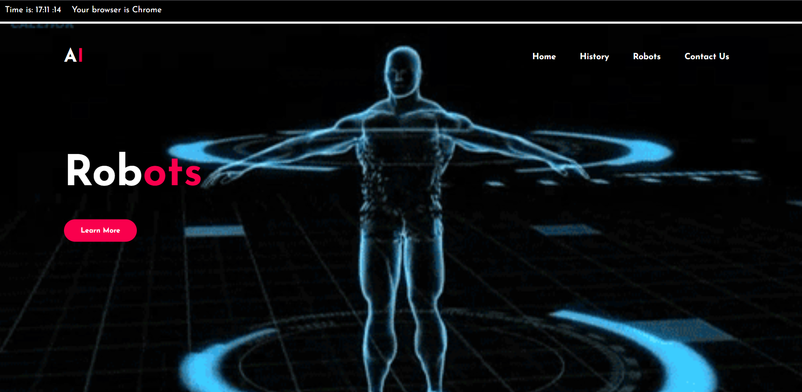

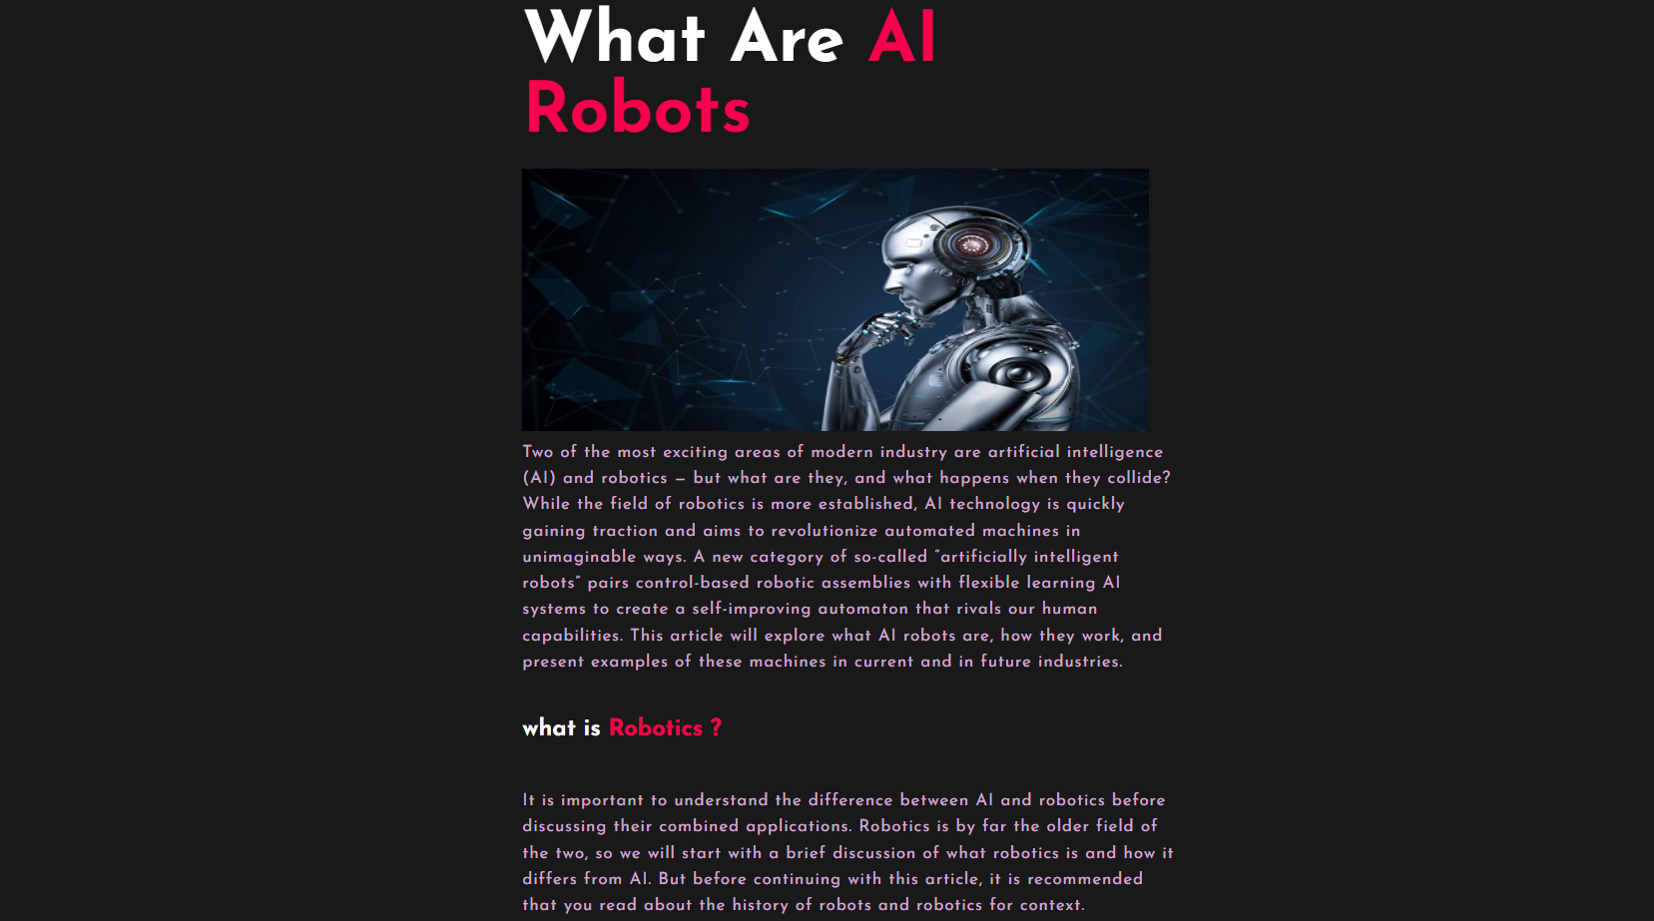

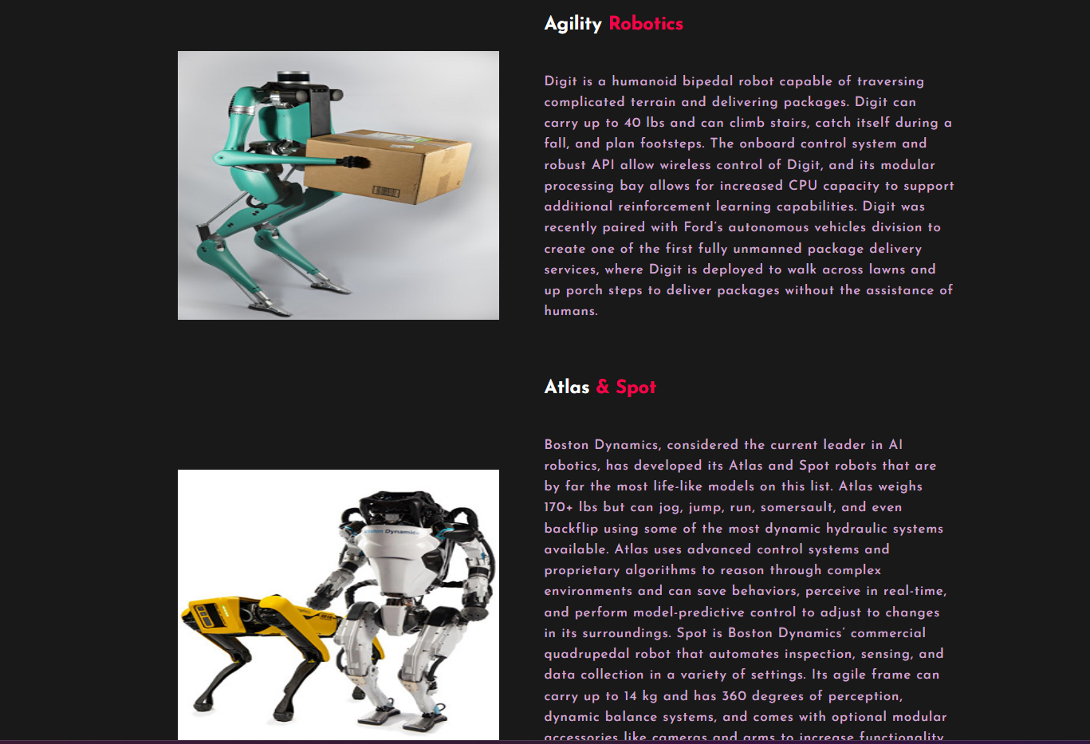

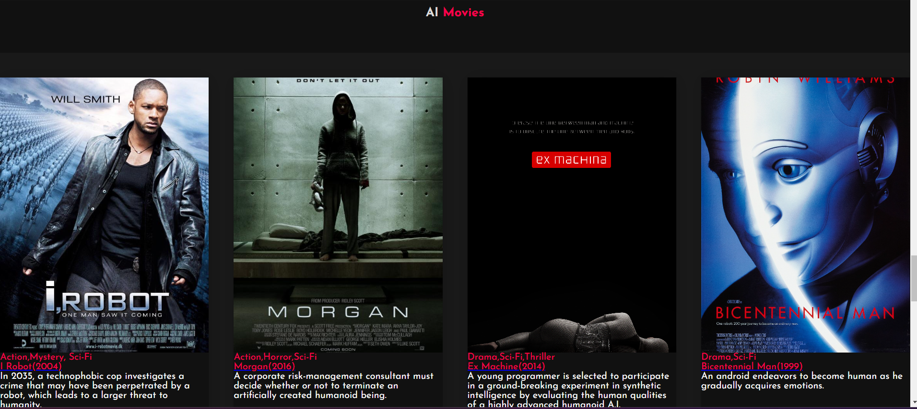

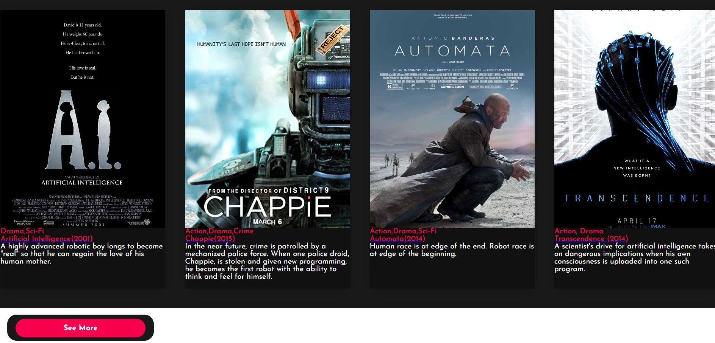

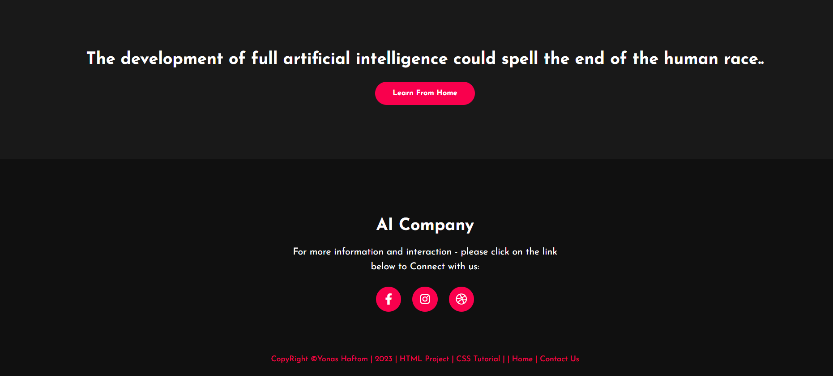

**Contact Us Page**

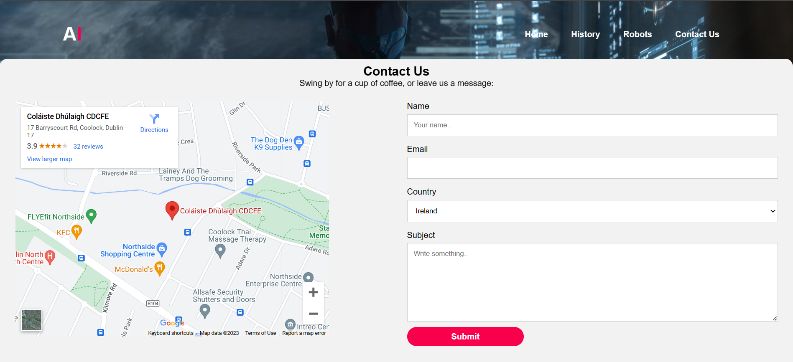

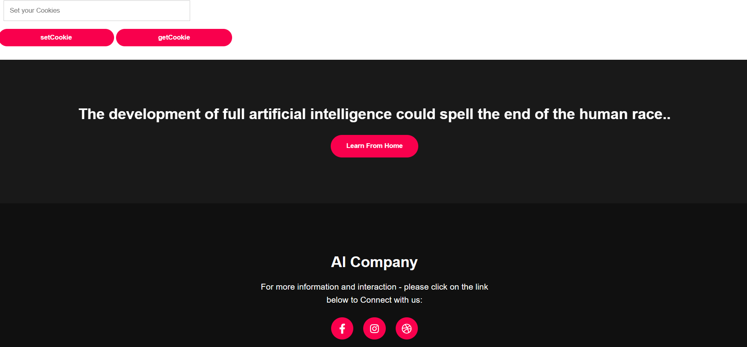

**A list of the 12 JavaScript used:**

1. Browser plug-in detection   **index.html**.
2. Status bar messages  **ContactUs.html**
3. Scrolling status bars    **Index.html**
4. Rollovers **Index.html (About Us Section and at the footer where “AI Company”).**
5. Cycling animations  **index.html**
6. Slide shows      **History.html**
7. Dynamic frames  **History.html**
8. Email verification      **ContactUs.html**
9. New windows  **Robots.html**
10. Cookies  **ContactUs.html**
11. Dynamic webpage updates **index.html, History.html, Robots.html, ContactUs.html**
12. Hit Page Counter index.html**History.html, Robots.html, ContactUs.html**

**Conclusion**

In this project, I learned so much about HTML CSS, and JavaScript which I find very interesting to connect all three together to get better quality web pages, however, java script was a bit difficult because I haven’t done it before its first time doing it I had to ask for help every time with each function and I had an issue with contact us page, I was trying to implemented status bar function to contact us form

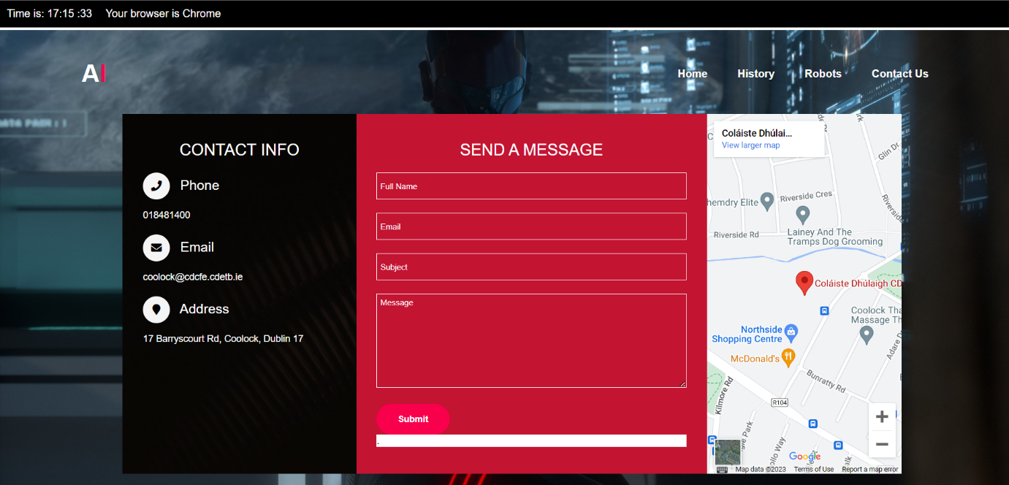

As you can see this was my first contact us page but I had to do it all over again because the status bar wasn’t Woking I believed the style was interacting so it didn’t show the status bar when I clicked submit button. Then I created another form and separate the CSS from all page then it was working well

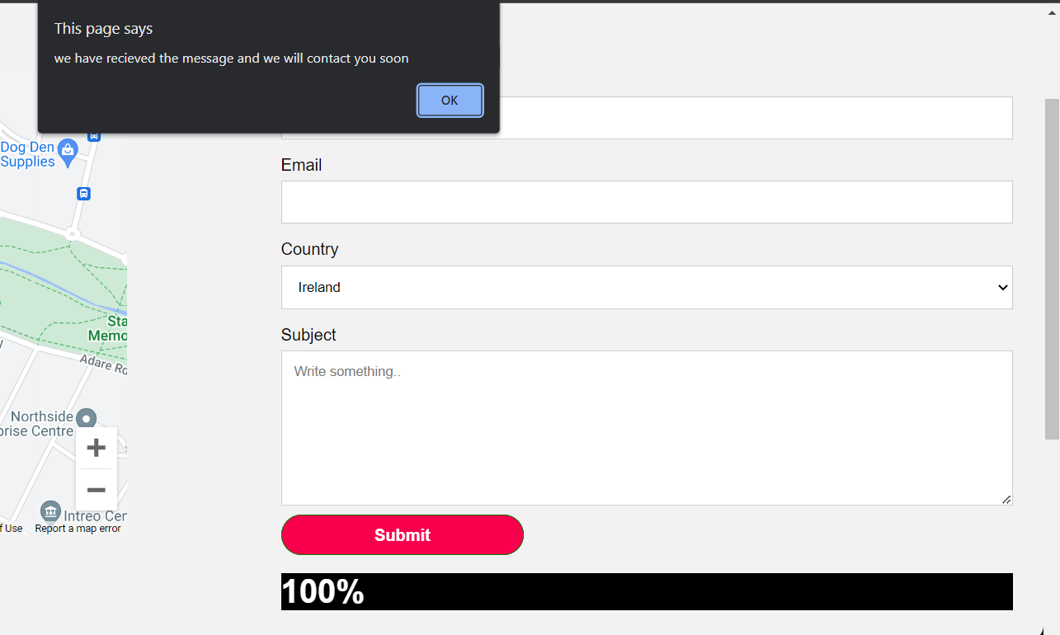

Overall, the project was fascinating I like the fact that it gave me so much knowledge that will help and support me in the future and I might take this course as a future occupation.

# Bibliography

EDUCBA. (n.d.). *www.educba.com*. Retrieved from https://www.educba.com/versions-of-html/

Hostinger. (n.d.). *Hostinger.com*. Retrieved from https://www.hostinger.com/tutorials/what-is-html

JanbaskDigitalDesign. (n.d.). *JanbaskDigitalDesig.com*. Retrieved from https://www.janbaskdigitaldesign.com/blogs/w3c-validation/#:~:text=W3C%20validation%20reduces%20the%20code%20size%20on%20your,languages%2C%20dynamic%20pages%2C%20multimedia%20presentations%2C%20and%20much%20more.